Home Network Setup
Two LANs connected through a simulated cable WAN in Cisco Packet Tracer
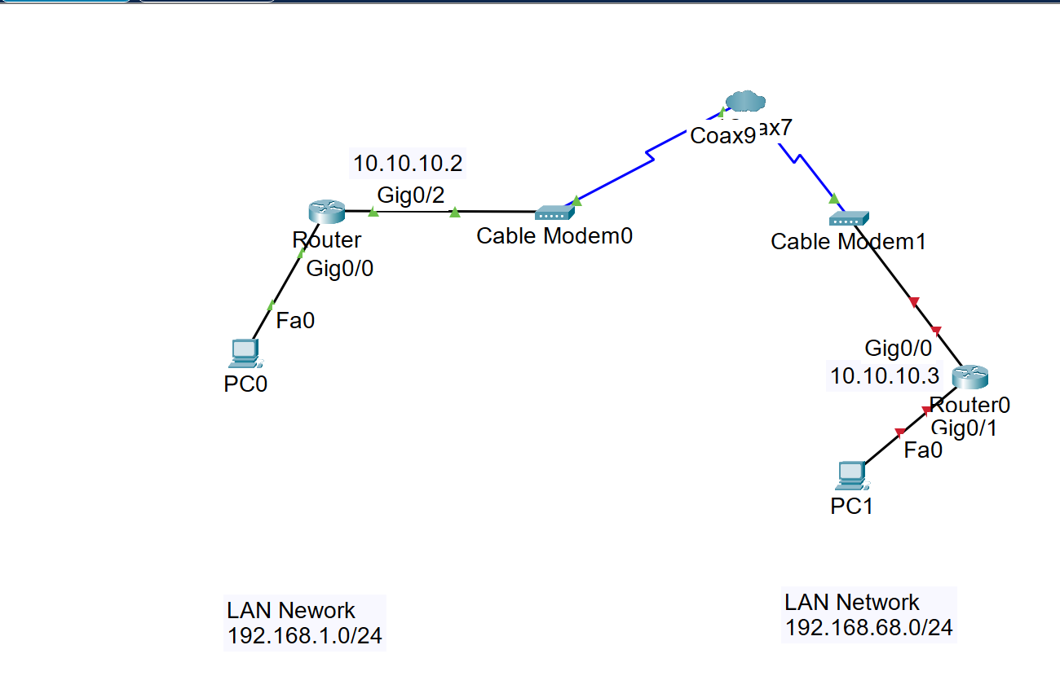
Figure 1. Packet Tracer topology supplied for this lab.
Important addressing assumption: The image labels the WAN interfaces as 10.10.10.2 and 10.10.10.3. This guide uses subnet mask 255.255.0.0 (/16) on both WAN interfaces. Because a PC1 host address was not specified, this guide assigns PC1 the address 192.168.68.51/24 with default gateway 192.168.68.1.

Learning objectives
- Assign correct IP addresses, masks, and default gateways.
- Configure Cisco router interfaces and bring them online.
- Add static routes so the two LANs can reach each other.
- Verify the topology with show commands, ping, and traceroute.

1. Network design and addressing
This lab contains three IP networks. The cloud and cable modems act as a Layer 2 path between the routers; they do not route traffic. Routing is performed by the two Cisco routers.
Network | Purpose | Subnet mask | Usable host range
192.168.1.0/24 | Left LAN: PC0 and R1 G0/0 | 255.255.255.0 | 192.168.1.1-192.168.1.254
10.10.0.0/16 | Cable WAN between R1 and R2 | 255.255.0.0 | 10.10.0.1-10.10.255.254
192.168.68.0/24 | Right LAN: R2 G0/1 and PC1 | 255.255.255.0 | 192.168.68.1-192.168.68.254

Device | Interface | IP address / prefix | Default gateway or next hop
PC0 | FastEthernet0 | 192.168.1.51/24 | 192.168.1.1
R1 (left router) | GigabitEthernet0/0 | 192.168.1.1/24 | Directly connected LAN
R1 (left router) | GigabitEthernet0/2 | 10.10.10.2/16 | Route to 192.168.68.0 via 10.10.10.3
R2 (right router) | GigabitEthernet0/0 | 10.10.10.3/16 | Route to 192.168.1.0 via 10.10.10.2
R2 (right router) | GigabitEthernet0/1 | 192.168.68.1/24 | Directly connected LAN
PC1 | FastEthernet0 | 192.168.68.51/24 | 192.168.68.1

Why the WAN is 10.10.0.0/16: With mask 255.255.0.0, both 10.10.10.2 and 10.10.10.3 belong to the same 10.10.0.0/16 network. That allows the router WAN interfaces to communicate directly through the cable modem and cloud bridge.

2. Place and cable the devices
1. Place two routers, two cable modems, one PT-Cloud, and two PCs in the Logical workspace.
2. Connect PC0 FastEthernet0 to R1 GigabitEthernet0/0.
3. Connect R1 GigabitEthernet0/2 to Cable Modem0 Ethernet.
4. Connect Cable Modem0 coaxial to a PT-Cloud coaxial port (shown as Coaxial9 in the image).
5. Connect another PT-Cloud coaxial port (shown as Coaxial7) to Cable Modem1 coaxial.
6. Connect Cable Modem1 Ethernet to R2 GigabitEthernet0/0.
7. Connect R2 GigabitEthernet0/1 to PC1 FastEthernet0.
Connection | Recommended cable
PC to router Ethernet | Copper straight-through or Automatic Connection
Router to cable modem Ethernet | Copper straight-through
Cable modem to PT-Cloud | Coaxial

Link lights in the uploaded image: The right-side links are red. This normally means an interface is shutdown, the cable is connected to the wrong port, or the cloud coaxial mapping is incomplete. The no shutdown commands in this guide should bring router links online after the cabling and cloud mapping are correct.

3. Configure the PT-Cloud and cable path
1. Open the PT-Cloud and select the Config tab.
2. Verify that the two coaxial interfaces used in the topology are enabled.
3. Under the Cable or Coaxial configuration, associate the first coaxial port with the second coaxial port so traffic can cross the cloud.
4. Confirm that Cable Modem0 and Cable Modem1 use their Ethernet and coaxial ports. The cable modems do not require IP addresses for this lab.
5. Wait several seconds for the link indicators to turn green after the router interfaces are enabled.
Packet Tracer version difference: The exact PT-Cloud menu labels can differ by Packet Tracer version. If the coaxial links are already green, the cloud path is already mapped and no additional cloud configuration is necessary.

4. Configure PC0
Open PC0 and select Desktop > IP Configuration. Enter:
Setting | Value
IP address | 192.168.1.51
Subnet mask | 255.255.255.0
Default gateway | 192.168.1.1
DNS server | Not required for this lab

Why the gateway matters: PC0 can reach devices in 192.168.1.0/24 directly. For destinations outside that subnet, including PC1, PC0 sends the packet to 192.168.1.1.

5. Configure R1, the left router
Open the left router CLI. If Packet Tracer asks whether to enter the initial configuration dialog, type no and press Enter.
R1 complete configuration
enable
configure terminal
hostname R1
interface gigabitEthernet 0/0
description LAN-to-PC0
ip address 192.168.1.1 255.255.255.0
no shutdown
exit
interface gigabitEthernet 0/2
description WAN-to-Cable-Modem0
ip address 10.10.10.2 255.255.0.0
no shutdown
exit
ip route 192.168.68.0 255.255.255.0 10.10.10.3
end
copy running-config startup-config

Interface numbering: Use show ip interface brief to confirm the names available on your router. If your model uses GigabitEthernet0/0/0 or GigabitEthernet0/0/1, replace the interface names in the commands while keeping the same IP plan.

What the static route means: To reach the remote network 192.168.68.0/24, R1 forwards packets to the next-hop WAN address 10.10.10.3, which belongs to R2.
Verify R1
show ip interface brief
show ip route
show running-config interface gigabitEthernet 0/0
show running-config interface gigabitEthernet 0/2

Expected routing entries on R1:
C 192.168.1.0/24 is directly connected, GigabitEthernet0/0
C 10.10.0.0/16 is directly connected, GigabitEthernet0/2
S 192.168.68.0/24 [1/0] via 10.10.10.3

6. Configure R2, the right router
R2 complete configuration
enable
configure terminal
hostname R2
interface gigabitEthernet 0/0
description WAN-to-Cable-Modem1
ip address 10.10.10.3 255.255.0.0
no shutdown
exit
interface gigabitEthernet 0/1
description LAN-to-PC1
ip address 192.168.68.1 255.255.255.0
no shutdown
exit
ip route 192.168.1.0 255.255.255.0 10.10.10.2
end
copy running-config startup-config

What the static route means: To return traffic to PC0 and the 192.168.1.0/24 network, R2 forwards packets to R1 at 10.10.10.2.
Verify R2
show ip interface brief
show ip route
show running-config interface gigabitEthernet 0/0
show running-config interface gigabitEthernet 0/1

Expected routing entries on R2:
C 10.10.0.0/16 is directly connected, GigabitEthernet0/0
C 192.168.68.0/24 is directly connected, GigabitEthernet0/1
S 192.168.1.0/24 [1/0] via 10.10.10.2

7. Configure PC1
Open PC1 and select Desktop > IP Configuration. Enter:
Setting | Value
IP address | 192.168.68.51
Subnet mask | 255.255.255.0
Default gateway | 192.168.68.1
DNS server | Not required for this lab

PC1 address selection: PC1 may use another unused host address from 192.168.68.2 through 192.168.68.254. Do not assign 192.168.68.1 to PC1 because that address belongs to R2 GigabitEthernet0/1.

8. Test the network in a logical order
Test one segment at a time. Do not begin with the end-to-end ping; a failed final ping does not identify which segment is misconfigured.

8.1 Verify router interfaces
Run on both routers
show ip interface brief

All four configured interfaces should show Status up and Protocol up. Example:
R1# show ip interface brief
Interface IP-Address OK? Method Status Protocol
GigabitEthernet0/0 192.168.1.1 YES manual up up
GigabitEthernet0/2 10.10.10.2 YES manual up up
R2# show ip interface brief
Interface IP-Address OK? Method Status Protocol
GigabitEthernet0/0 10.10.10.3 YES manual up up
GigabitEthernet0/1 192.168.68.1 YES manual up up

8.2 Test local LAN connections
Run from the PC Command Prompt
PC0> ping 192.168.1.1
PC1> ping 192.168.68.1

8.3 Test the WAN connection between the routers
R1# ping 10.10.10.3
R2# ping 10.10.10.2

8.4 Test each router to the remote LAN
R1# ping 192.168.68.1
R1# ping 192.168.68.51
R2# ping 192.168.1.1
R2# ping 192.168.1.51

8.5 Ping PC0 to PC1
On PC0, open Desktop > Command Prompt and run:
ping 192.168.68.51

A successful result should resemble:
Pinging 192.168.68.51 with 32 bytes of data:
Reply from 192.168.68.51: bytes=32 time<1ms TTL=126
Reply from 192.168.68.51: bytes=32 time<1ms TTL=126
Reply from 192.168.68.51: bytes=32 time<1ms TTL=126
Reply from 192.168.68.51: bytes=32 time<1ms TTL=126
Ping statistics for 192.168.68.51:
Packets: Sent = 4, Received = 4, Lost = 0 (0% loss)

8.6 Ping PC1 back to PC0
On PC1, run:
ping 192.168.1.51

First ping timeout: The first echo request may time out while ARP entries are learned. Repeat the ping. Continued timeouts indicate a configuration or link problem.

8.7 Trace the routed path
PC0> tracert 192.168.68.51

Expected hops:
1 192.168.1.1
2 10.10.10.3
3 192.168.68.51

Packet Tracer output can vary slightly, but the path should cross R1 and R2 before reaching PC1.

8.8 Inspect ARP and routing information
PC0> arp -a
PC1> arp -a
R1# show arp
R1# show ip route
R2# show arp
R2# show ip route

No NAT is required: This is a routed private lab. Static routes provide reachability in both directions, so Network Address Translation is not needed for PC0-to-PC1 communication. NAT would be added only when modeling internet access or address translation requirements.

9. How the PC0-to-PC1 ping travels
1. PC0 compares 192.168.68.51 with its own /24 network and determines that PC1 is remote.
2. PC0 sends the Ethernet frame to its default gateway, R1 at 192.168.1.1.
3. R1 examines its routing table and matches the static route for 192.168.68.0/24.
4. R1 forwards the packet to next hop 10.10.10.3 through GigabitEthernet0/2.
5. Cable Modem0, the PT-Cloud, and Cable Modem1 bridge the frame across the simulated cable WAN.
6. R2 receives the packet, recognizes 192.168.68.0/24 as directly connected, and forwards it to PC1.
7. PC1 sends the echo reply to default gateway 192.168.68.1. R2 uses its static route to return the packet through R1 to PC0.

10. Troubleshooting checklist
Symptom | Likely cause | Correction
Interface says administratively down | The interface is shutdown | Enter interface configuration mode and run no shutdown.
Interface is up/down | Layer 2 problem or incomplete cloud path | Verify ports, cable types, cable modem connections, and PT-Cloud coaxial mapping.
PC cannot ping its gateway | Wrong PC IP, mask, gateway, cable, or router LAN interface | Compare the PC settings with the address table and verify the local router interface is up/up.
Routers cannot ping 10.10.10.2/10.10.10.3 | WAN mask mismatch or broken cable/cloud link | Use 255.255.0.0 on both WAN interfaces and verify the complete coaxial path.
R1 reaches R2 but not PC1 | Missing route, R2 LAN interface down, or PC1 settings wrong | Check show ip route, R2 G0/1, and PC1 gateway 192.168.68.1.
PC0 can reach R2 but not PC1 | PC1 firewall-like state, wrong address, or wrong gateway | Verify PC1 is 192.168.68.51/24 and retest from R2 first.
Ping works only one direction | Return static route or default gateway is missing | Ensure R2 has a route to 192.168.1.0/24 and both PCs have correct gateways.
First ping fails, later pings work | ARP resolution | This is normal; repeat the ping.

11. Useful reset and diagnostic commands
show running-config
show ip interface brief
show interfaces description
show ip route
show arp
show cdp neighbors
ping <destination-ip>
traceroute <destination-ip>
clear arp
clear ip route *

Use clear commands carefully: The clear commands remove learned information. They are useful for lab troubleshooting, but they are not required for the normal setup.

12. Final configuration checklist
Check | Expected result
PC0 configuration | 192.168.1.51/24, gateway 192.168.1.1
R1 LAN interface | G0/0 = 192.168.1.1/24, up/up
R1 WAN interface | G0/2 = 10.10.10.2/16, up/up
R1 static route | 192.168.68.0/24 via 10.10.10.3
R2 WAN interface | G0/0 = 10.10.10.3/16, up/up
R2 LAN interface | G0/1 = 192.168.68.1/24, up/up
R2 static route | 192.168.1.0/24 via 10.10.10.2
PC1 configuration | 192.168.68.51/24, gateway 192.168.68.1
End-to-end test | PC0 and PC1 receive four ping replies from each other

Lab completion standard: The setup is complete when all router interfaces are up/up, both static routes appear in the routing tables, each PC can ping its gateway, the router WAN interfaces can ping each other, and PC0 and PC1 can ping in both directions.

